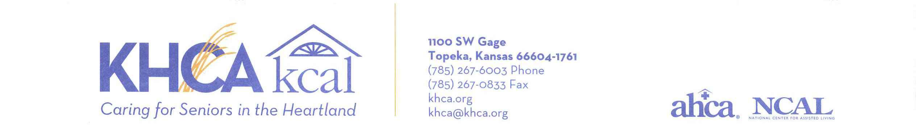

Annual Business Meeting

TO: KHCA/KCAL Members

FROM: Staci Cardenas, Chairperson Kansas Health Care Association

DATE: August 17, 2022

Enclosed are your materials for the Annual Business Meeting, held during the Kansas Health Care Association’s 72nd Annual Convention and Trade Show. Please plan to attend this meeting:

Friday, September 30, 2022
10:00- 11:00 AM

Kansas Star Event Center
785 Kansas Star Drive
Mulvane, KS 67110

Please remember you must be credentialed to be able to vote on any issues presented during the meeting.

